**Sindh:**

Shah Jahan Mosque

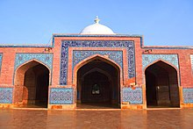

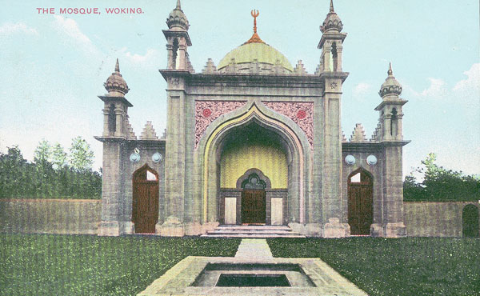

The **Shah Jahan Mosque** also known as the **Jamia Masjid of Thatta** , is a 17th-century building that serves as the central mosque for the city of Thatta, in the Pakistani province of Sindh. The mosque is considered to have the most elaborate display of tile work in South Asia, and is also notable for its geometric brick work - a decorative element that is unusual for Mughal-period mosques. It was built during the reign of Mughal emperor Shah Jahan, who bestowed it to the city as a token of gratitude, and is heavily influenced by Central Asian architecture - a reflection of Shah Jahan's campaigns near Samarkand shortly before the mosque was designed.